Date :04/01/2023 Seat No:

…………………………………………………......

**PRACTICAL NO.2**

**Aim:** Exploring and Managing Raster data: Adding raster layers, raster styling and

analysis, raster mosaicking and clipping.

**2A) Adding raster layers**

1. From menu bar select Layer → Add Layer → Add Raster Layer

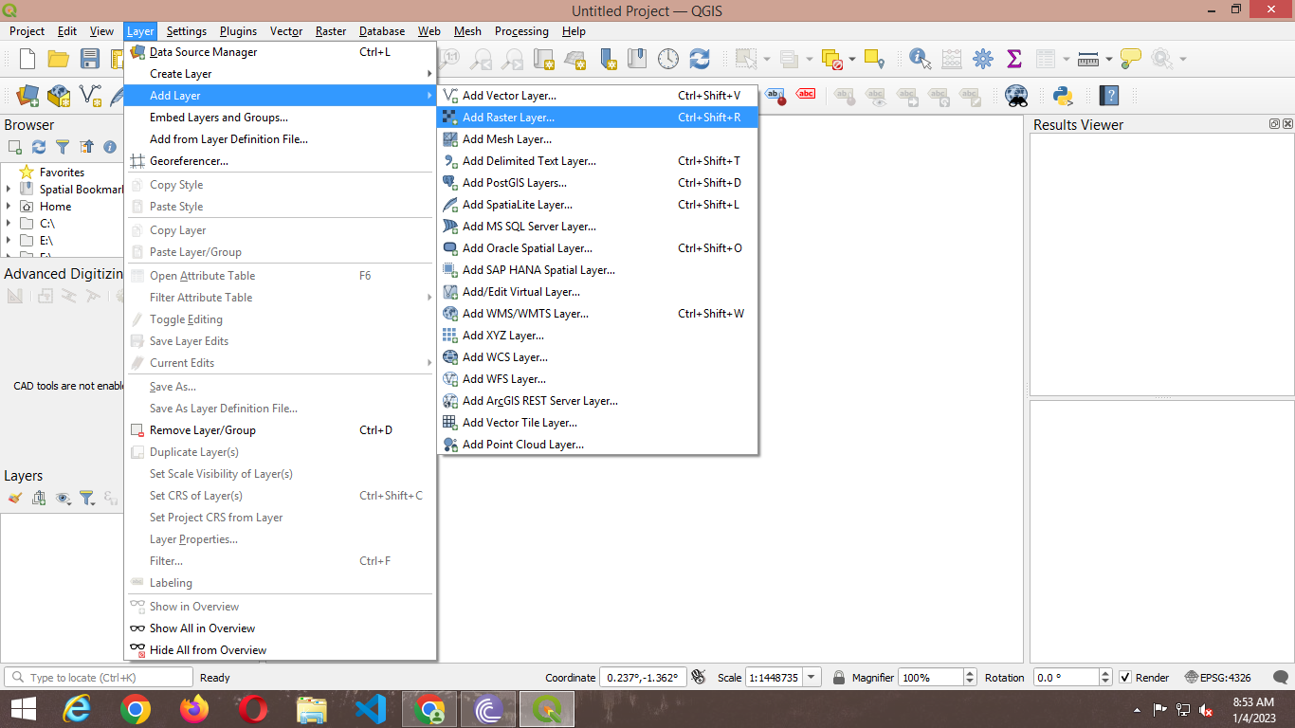

1. select two extract files .

**“E:\gis 1 myy\2pra\ gl_gpwv3_pdens_90_ascii_one\glds90ag60.asc”**

**“E:\gis 1 myy\2pra \gl_gpwv3_pdens_90_ascii_one\glds00ag60.asc”**

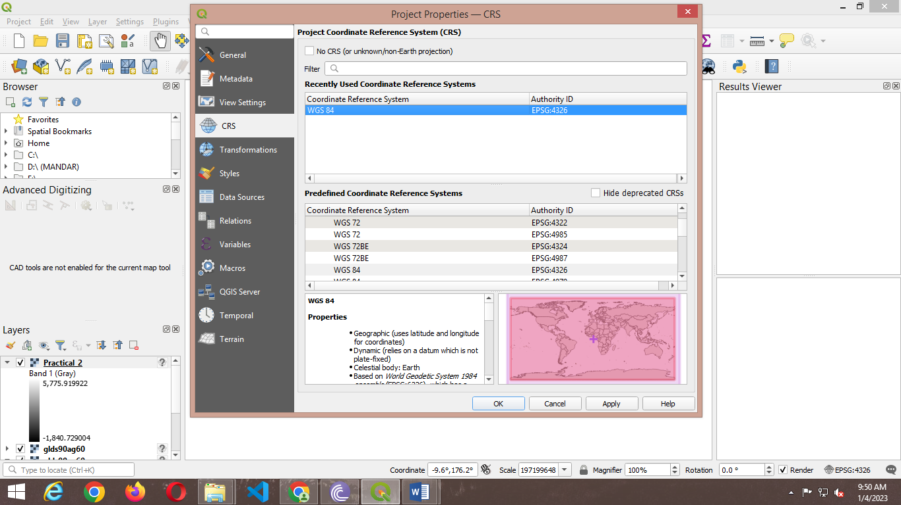

1. Go to Project → Properties OR Press the Set CRS option on bottom

right corner.

1. Select WGS 84 EPSG: 4326 and Press OK.

**2B ) Raster Styling and Analysis**

1. To start with analysis of population data, convert the pixel from grayscale to Color.

Select “glds90ag60.asc” Layer form layer Pane → select property OR double click on it.

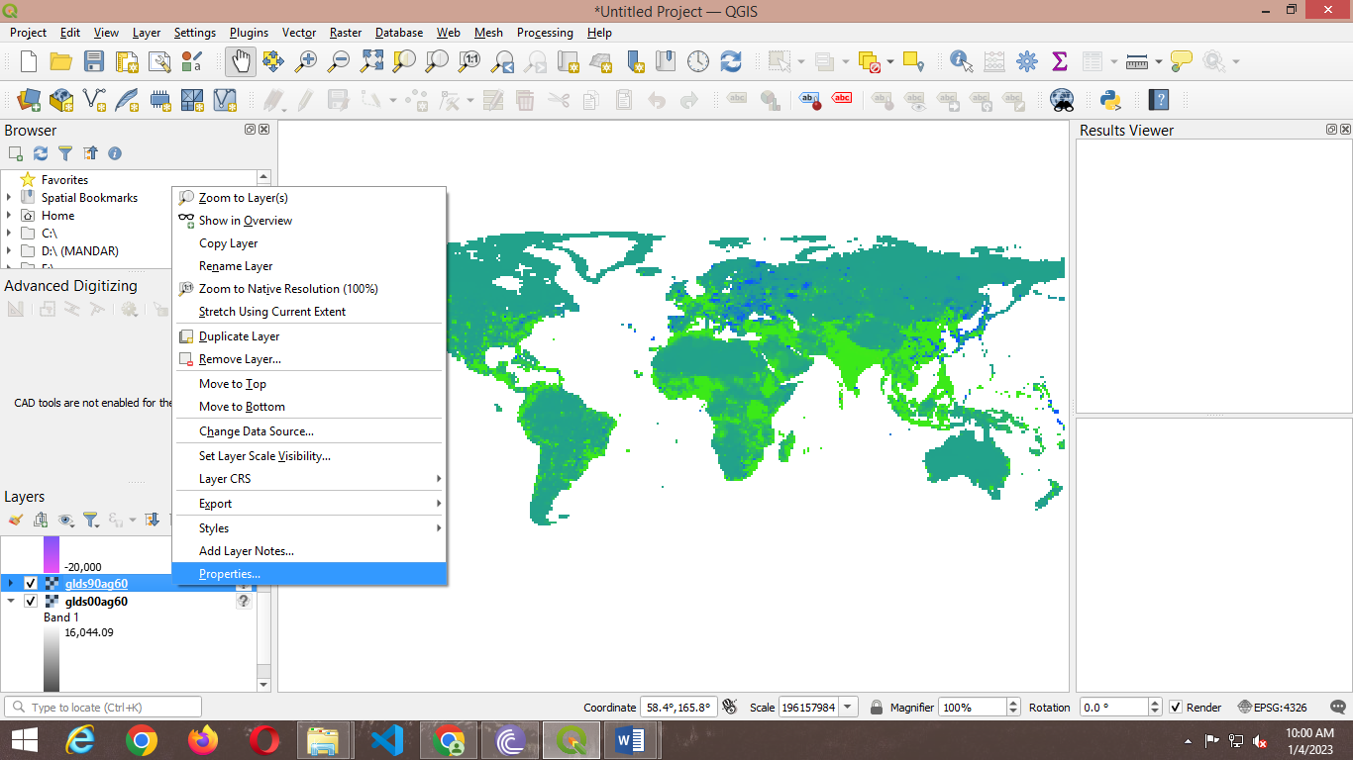

1. Select Symbology 🡪 Select singleband pseudocolor of render type.

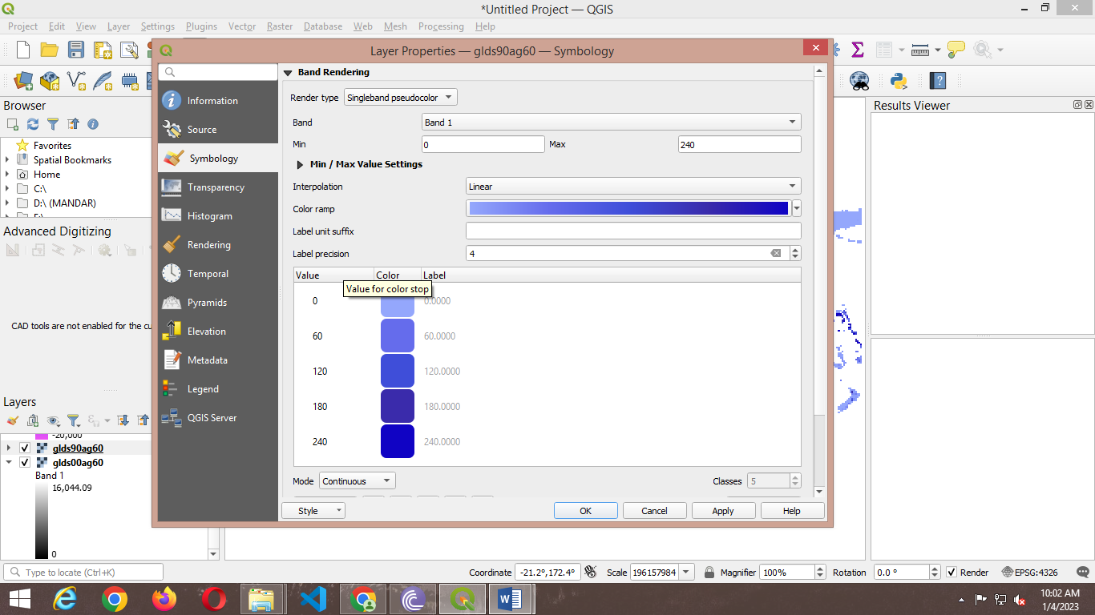

1. Press “APPLY”

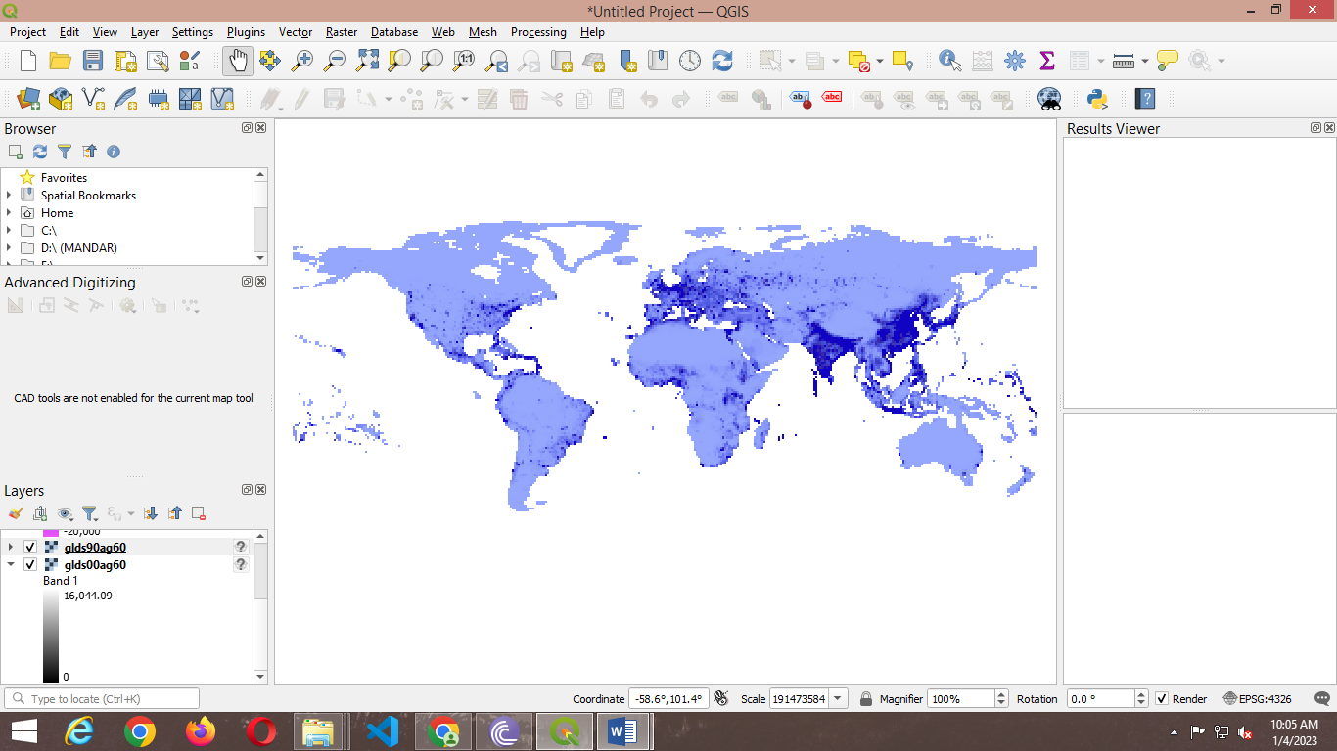

1. Go to Raster → Raster Calculator

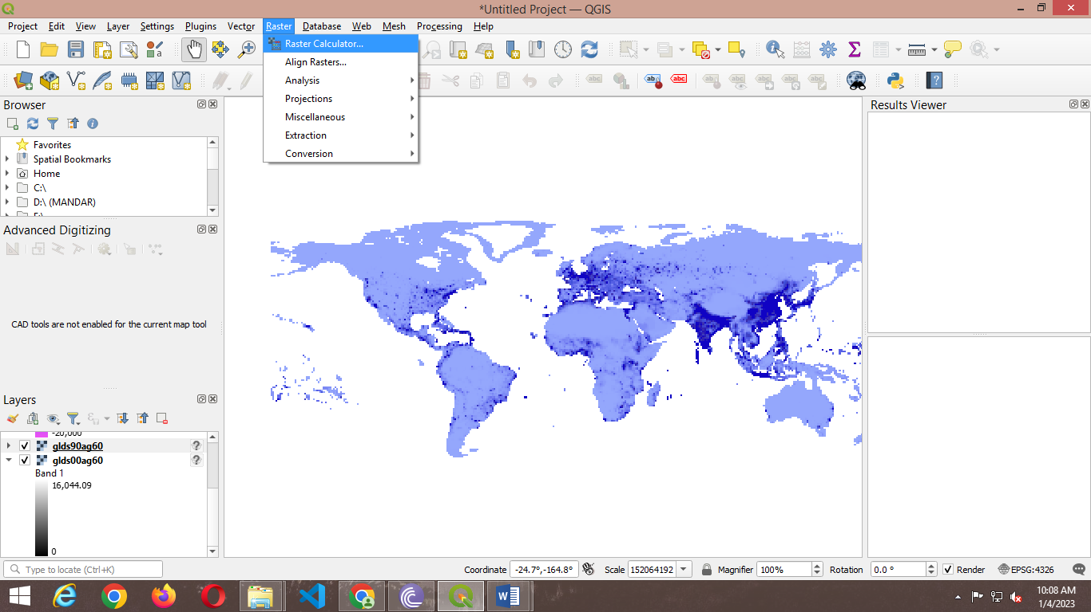

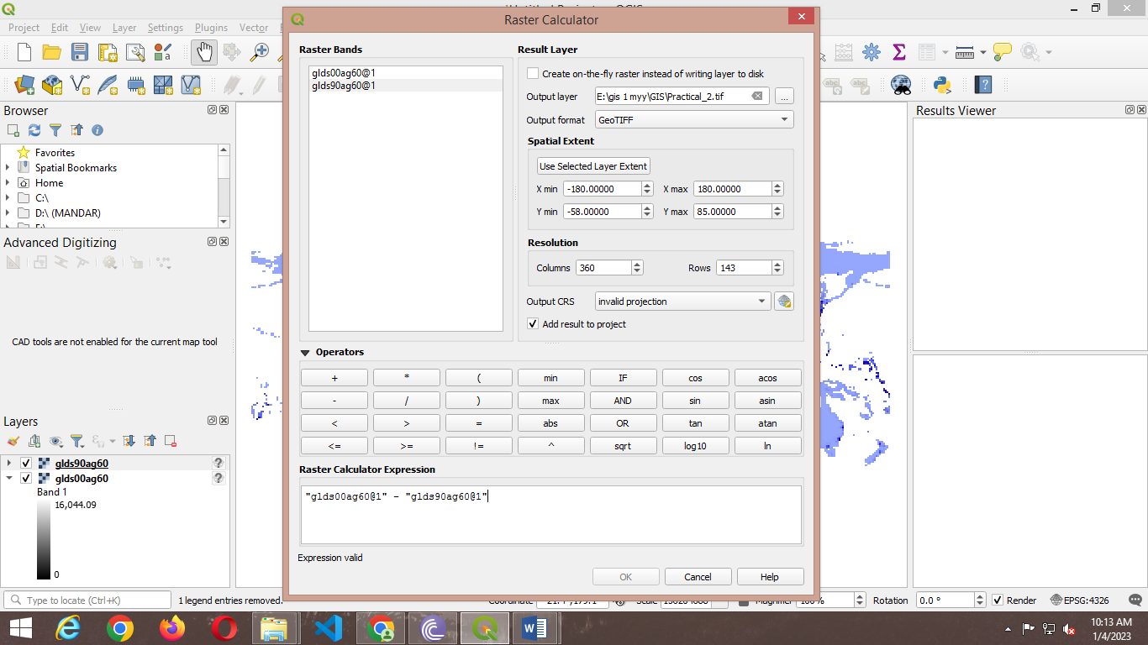

1. Put the expression "glds00ag60@1" - "glds90ag60@1"

Select the output file location & name and Press OK.

1. Select Symbology 🡪 Select singleband pseudocolor of render type.

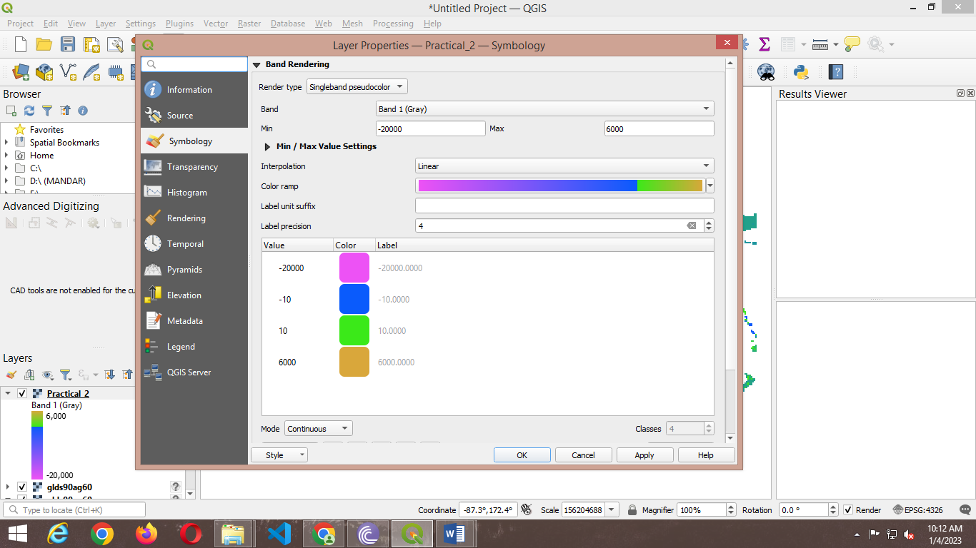

1. After All setting press ‘OK’. Layer will appear like

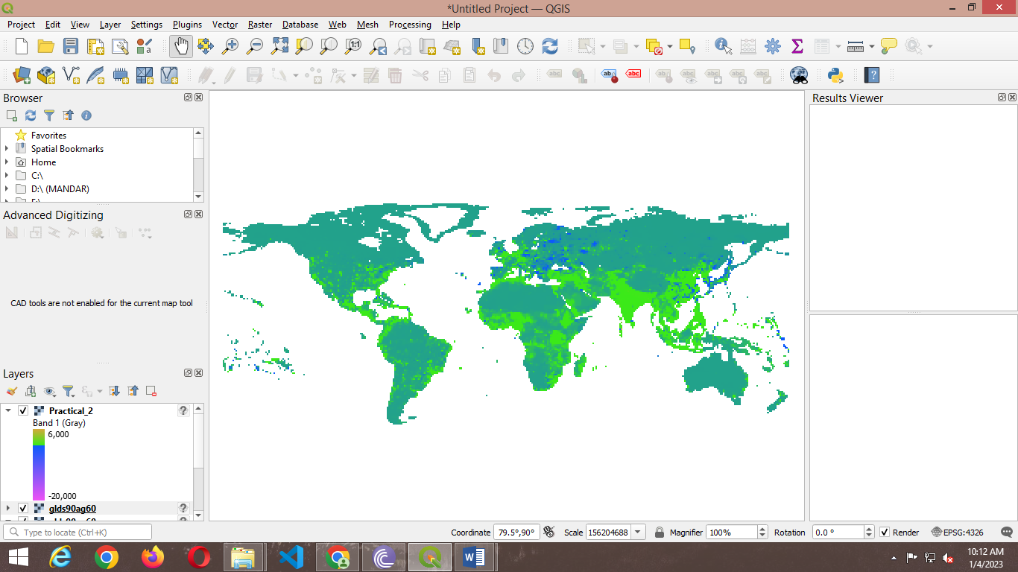

**2C ) Raster Mosaicking and Clipping**

1. Go to Layer → Add Layer → Add Raster Layer.

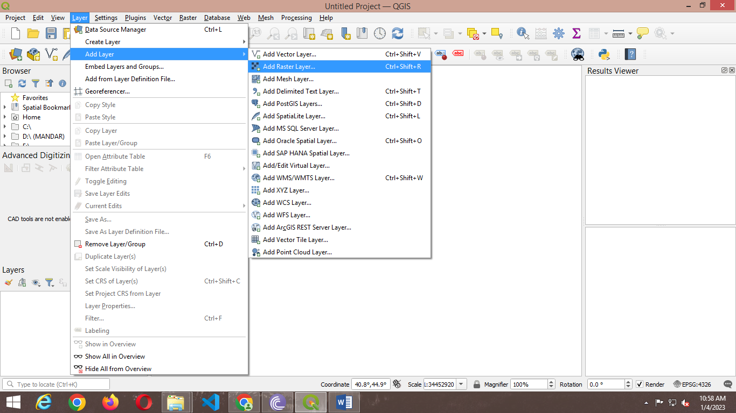

1. Select the following “.tif” raster images for India from data folder🡪 Press Open.

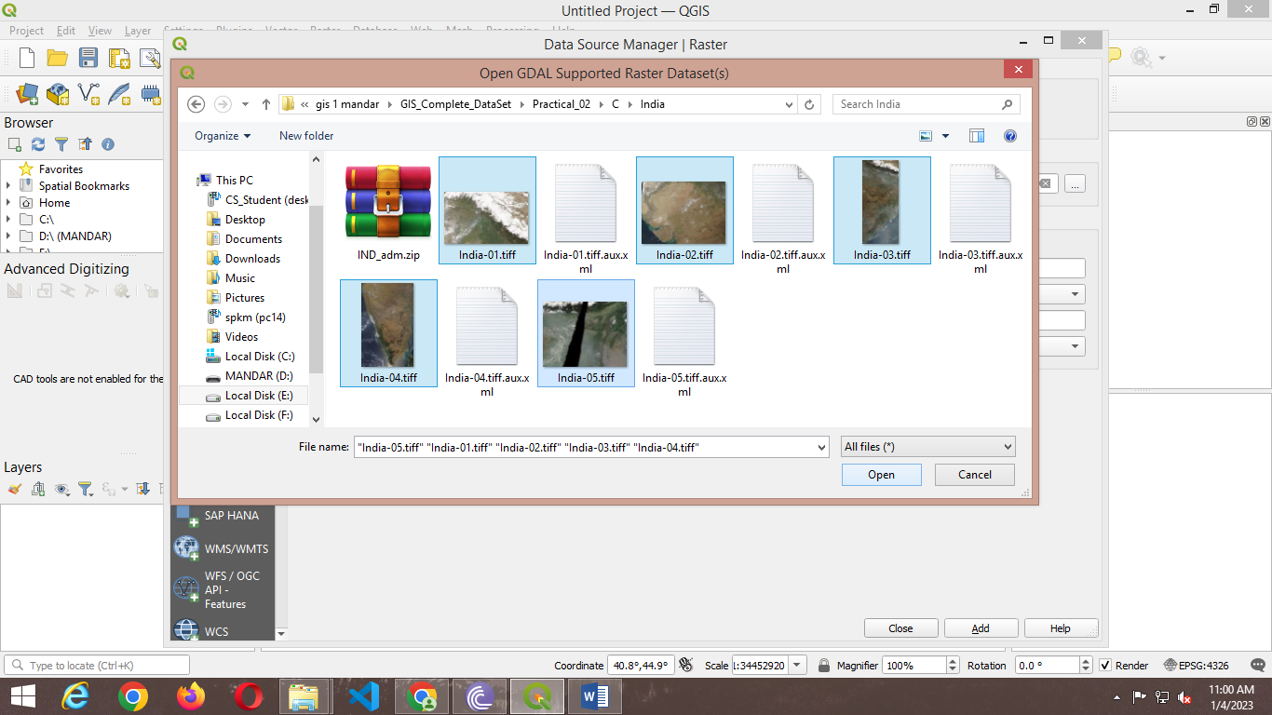

1. Go to Raster → Miscellaneous → Merge

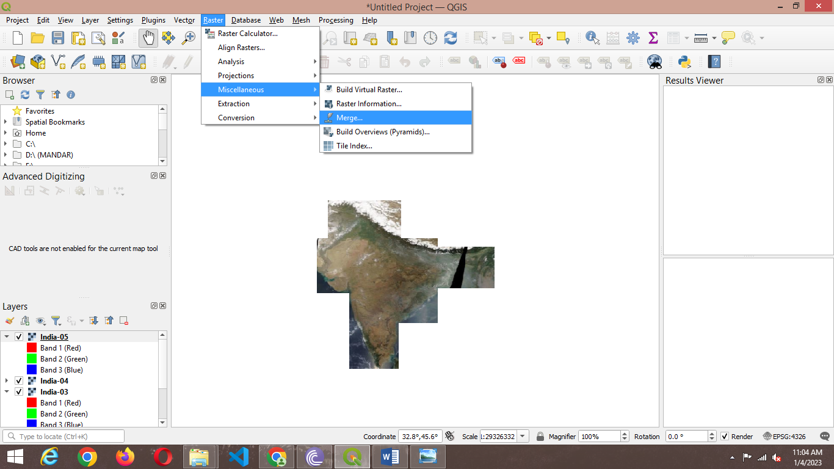

1. In the Merge dialog window Select all layers and Press OK.

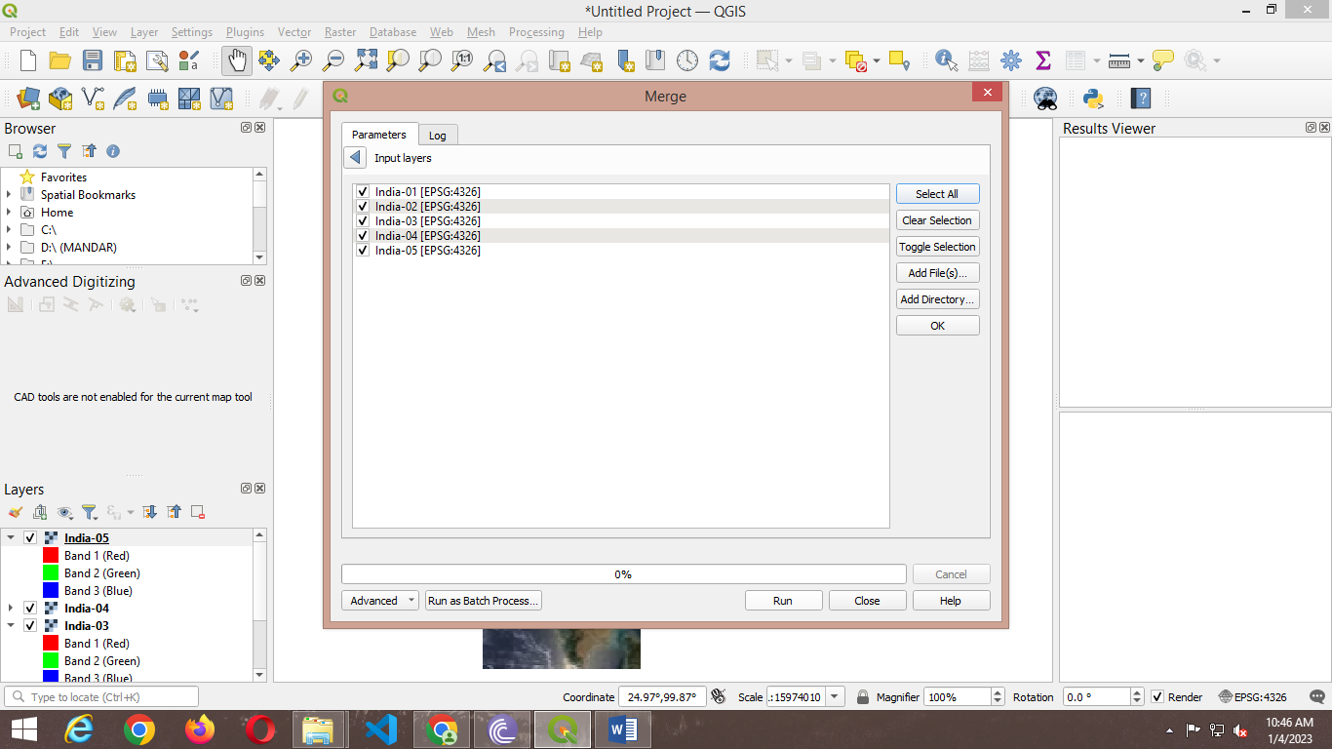

1. In Merge dialog window select a file name and location to save merged images.

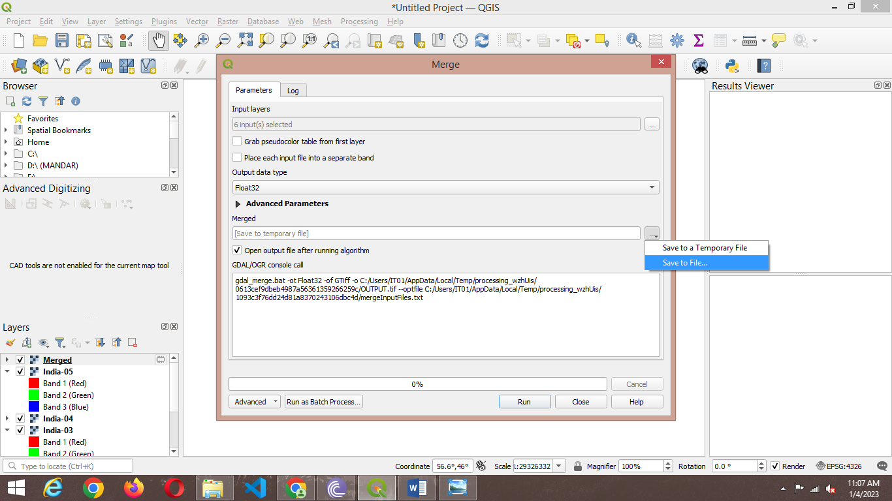

1. Press Run and after completion of operation close the Merge window dialog box.

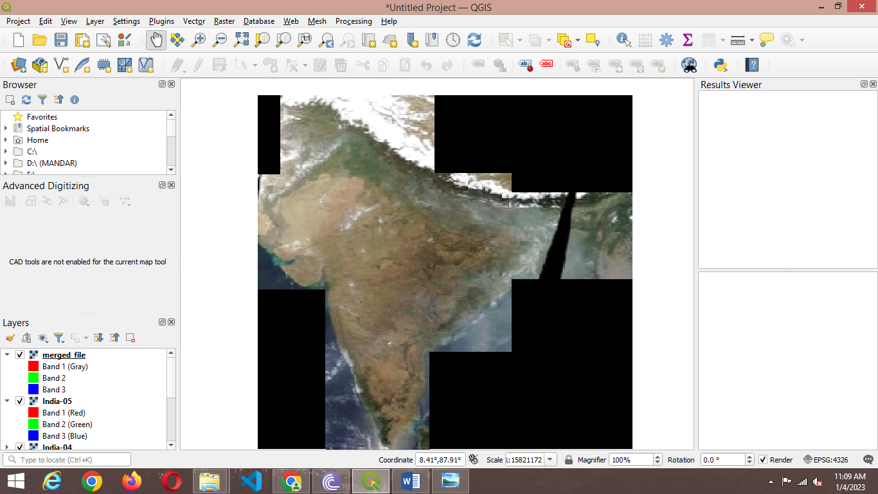

1. Go to Layer→ Add Vector Layer → Select E:\gis 1 myy\2pra\clip\IND_adm0.shp

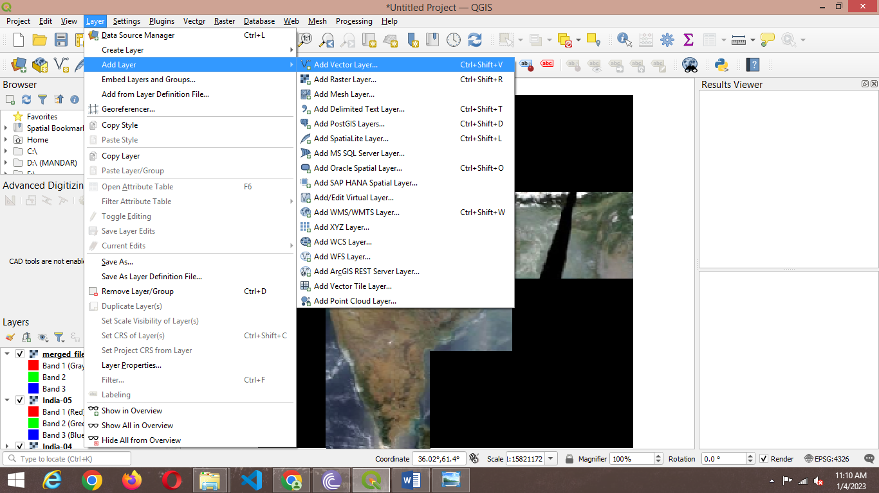

1. From layer properties → select symbology → select outline 🡪 The result will be

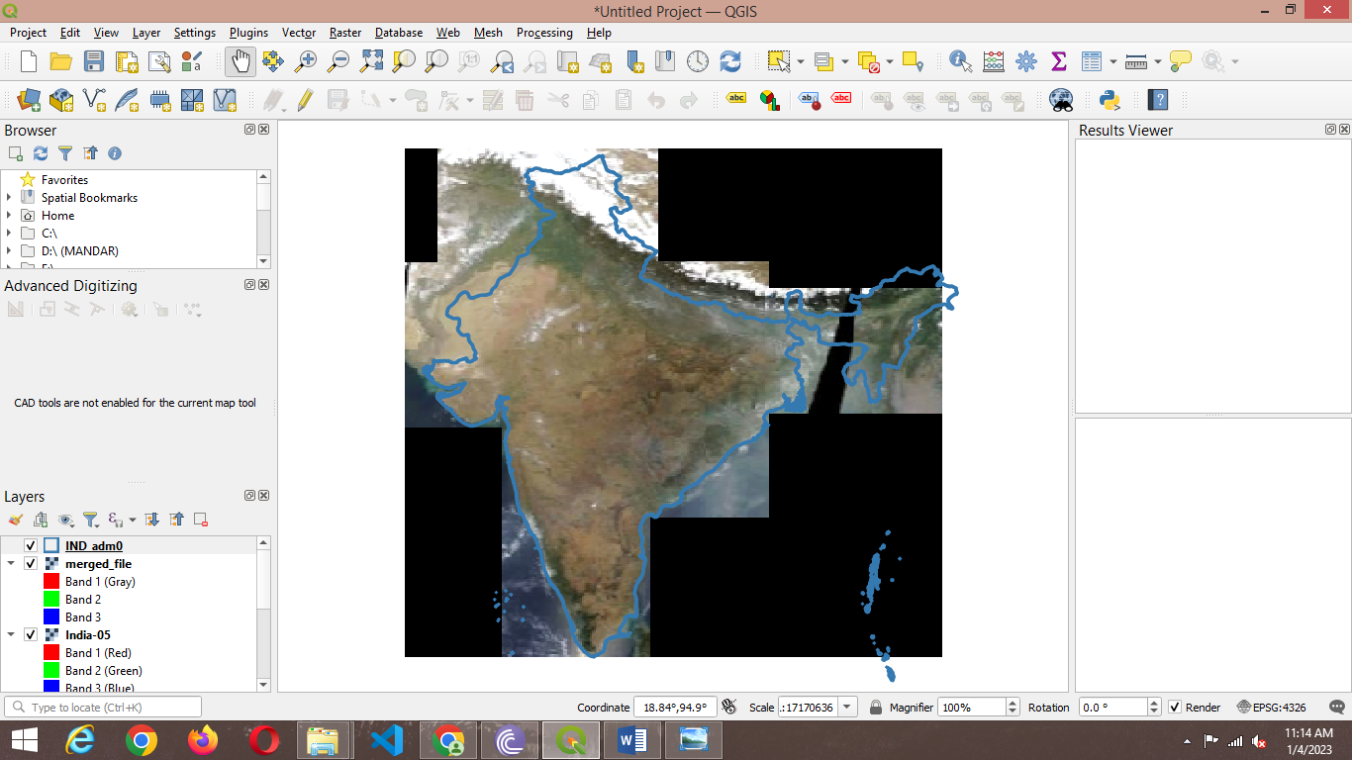

1. Go to Raster → Extraction → Clip Raster by Mask Layer

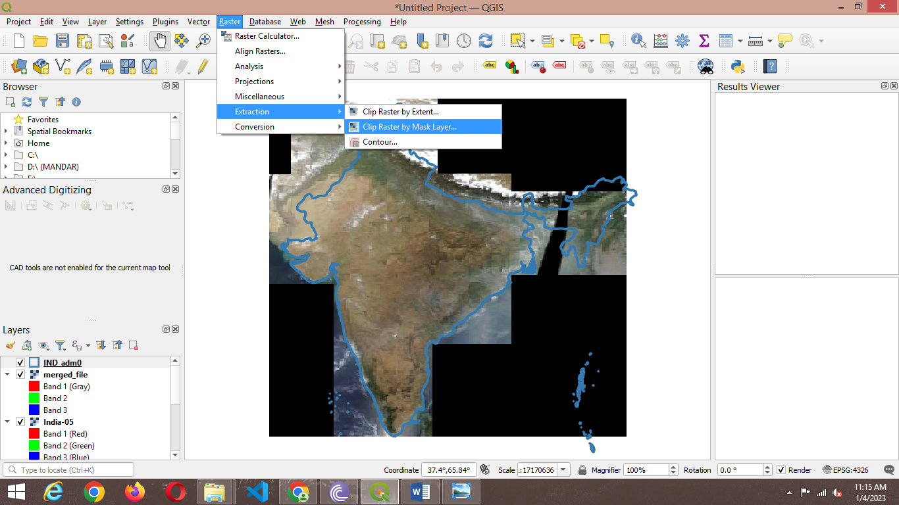

1. Press Run

